|  |  |  |  |  |  |  |
| --- | --- | --- | --- | --- | --- | --- |
| **NR** | **Volledige voor/achternaam** | **J/M** | **Geboortedatum** | **gewicht** | **Band/ Slip** | **poul code Niet invullen** |
| 1 |  |  |  |  |  |  |
| 2 |  |  |  |  |  |  |
| 3 |  |  |  |  |  |  |
| 4 |  |  |  |  |  |  |
| 5 |  |  |  |  |  |  |
| 6 |  |  |  |  |  |  |
| 7 |  |  |  |  |  |  |
| 8 |  |  |  |  |  |  |
| 9 |  |  |  |  |  |  |
| 10 |  |  |  |  |  |  |
| 11 |  |  |  |  |  |  |
| 12 |  |  |  |  |  |  |
| 13 |  |  |  |  |  |  |
| 14 |  |  |  |  |  |  |
| 15 |  |  |  |  |  |  |
| 16 |  |  |  |  |  |  |
| 17 |  |  |  |  |  |  |
| 18 |  |  |  |  |  |  |
| 19 |  |  |  |  |  |  |
| 20 |  |  |  |  |  |  |

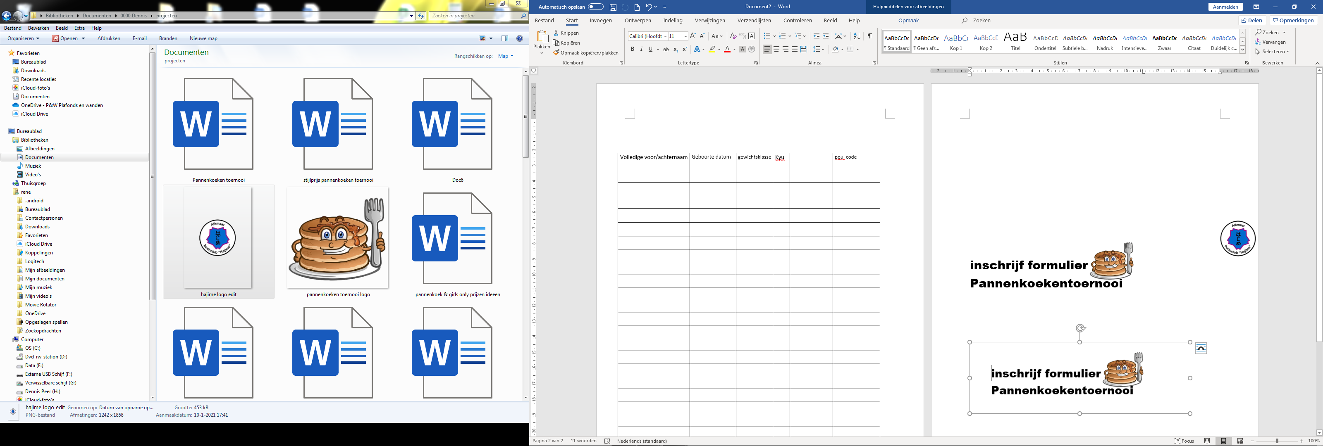

Naam sportschool : naam contact persoon : Adres : Telefoonnummer : Email adres :

WOC -Hajime Email: [wedstrijden@budoclubhajime.nl](mailto:wedstrijden@budoclubhajime.nl)

Inschrijven voor 30 september 2024 !!!